**SSDT Solutions – SSIS Packages**

**Table – DimGender**

Gender info about case

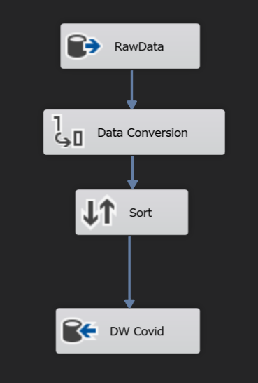

**Table – DimAgeGroup**

Info about ages of cases

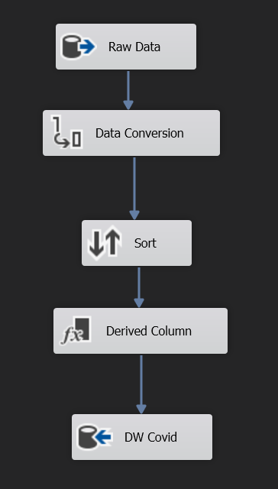

**Table – DimDHB**

Info about the District Health Board each case comes under

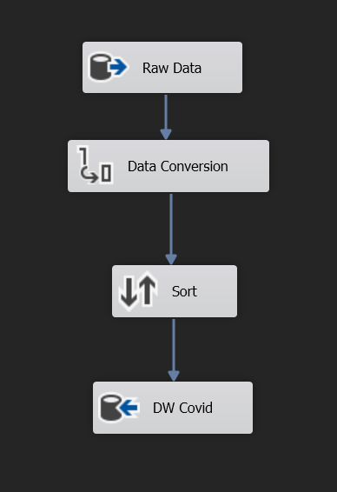

**Table – DimLastVisitedCountry**

Info about the last country visited by cases associated with travel

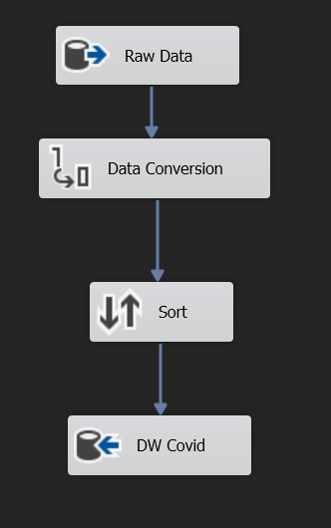

**Table – FactCovidCase**

Table to hold info about each individual Covid-19 case in NZ

